**Project Report Template**

1 INTRODUCTION

Video games are popular all over the world. They are enjoyed by all ages. Video game industry is huge and the spending on video games per year is huge too. Sales of different types of games vary widely between countries due to local preferences. According to the market research firm Super Data, as of May 2015, the global games market was worth USD 74.2 billion. By region, North America accounted for 19.73 billion dollars, Japan for 22.1 billion dollars, Europe for 59.70 billion dollars. There are different genres, publisher and platforms for video games. This project relates to the sales of these video games based on different regions and analyses the sales. Also I have analysed which genre, platform or publisher is the most popular and has maximum number of sales

1.1 Overview

In this the main goal was to analyse the sales of video games in different regions. The regions are North America, Europe, Japan, other countries and then the global sales (total of all the regions). The main idea was to visualize the sales for different genres, publishers and platforms. This would give the basic idea about the most popular genres, publishers and platforms amongst all. Also analysing the effect of genres on sales in different regions.

1.2 Purpose

Video game sales analysis is the process of collecting and analysing data about the sales of video games in order to understand market trends and consumer behaviour. This type of analysis can beuseful for a variety of purposes, including identifying the most popular games and genres, predicting future sales, and developing marketing strategies.

2 Problem Definition & Design Thinking

* 1. Empathy Map

An empathy map is a simple, easy-to-digest visual that captures knowledge about a user’s behaviours and attitudes. It is a useful tool to helps teams better understand their users. Creating an effective solution requires understanding the true problem and the person who is experiencing it. The exercise of creating the map helps participants consider things from the user’s perspective along with his or her goals and challenges.

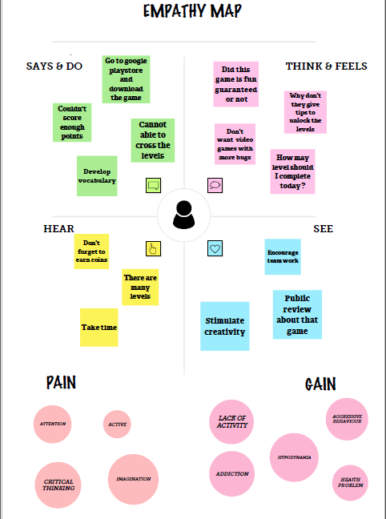

* 1. Ideation & Brainstorming Map

Brainstorming provides a free and open environment that encourages everyone within a team to participate in the creative thinking process that leads to problem solving. Prioritizing volume over value, out-of-the-box ideas are welcome and built upon, and all participants are encouraged to collaborate, helping each other develop a rich amount of 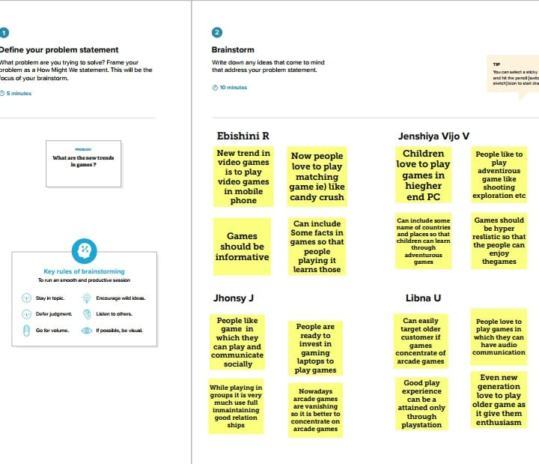creative solutions.

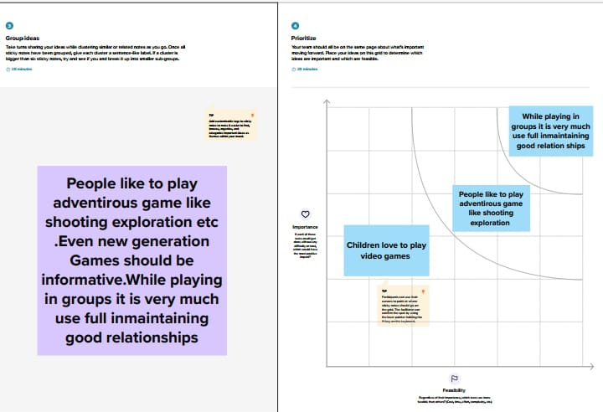

1. 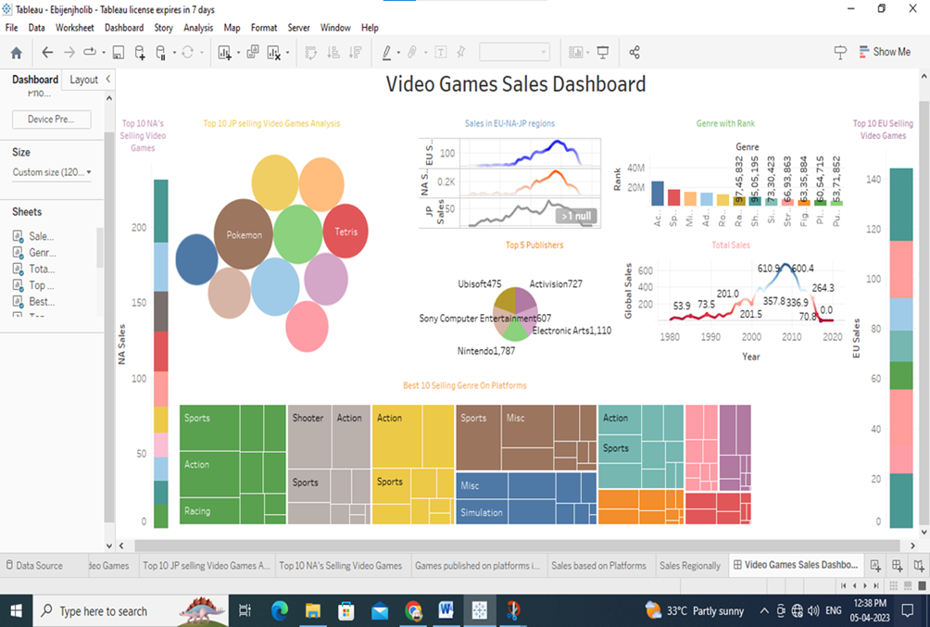Result

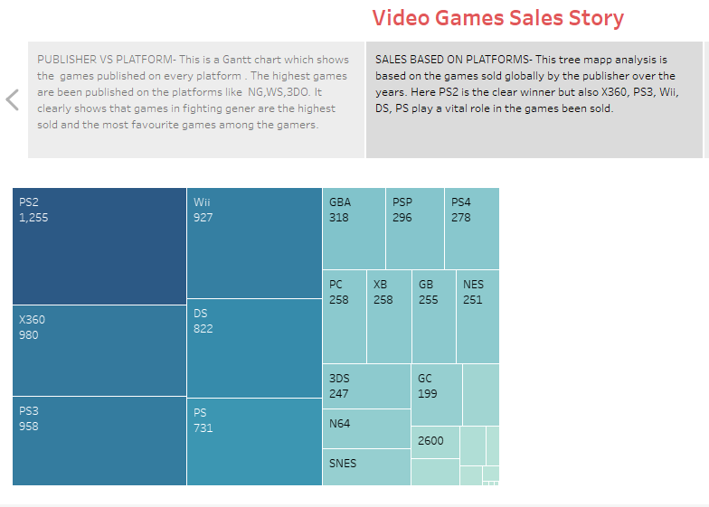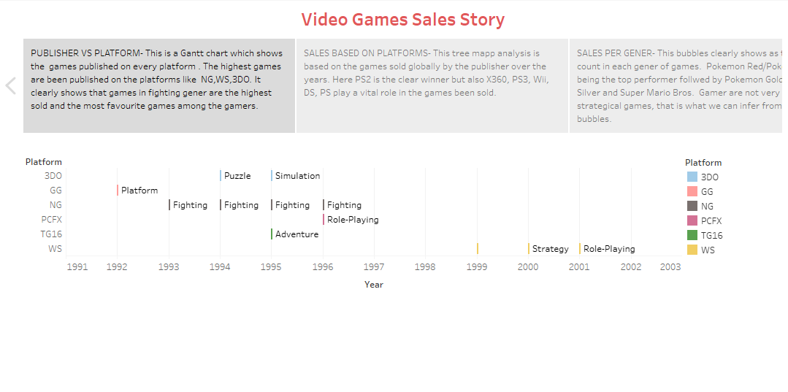

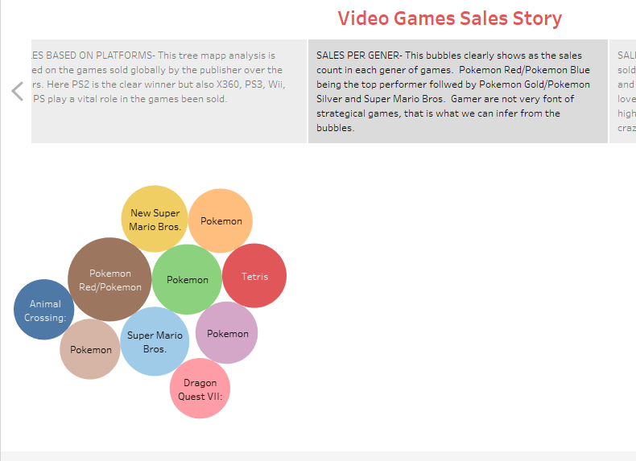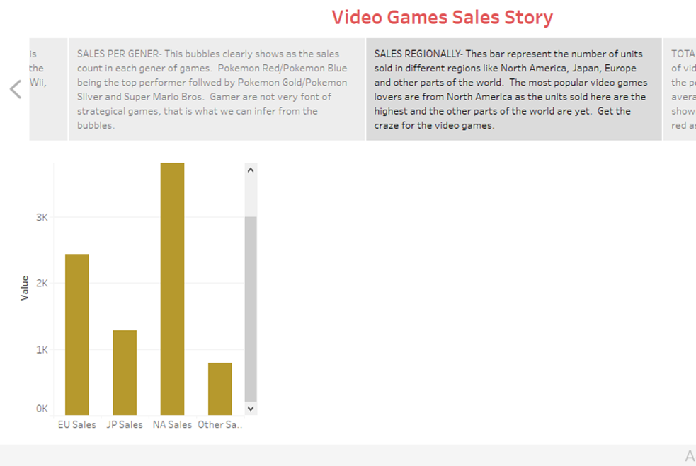

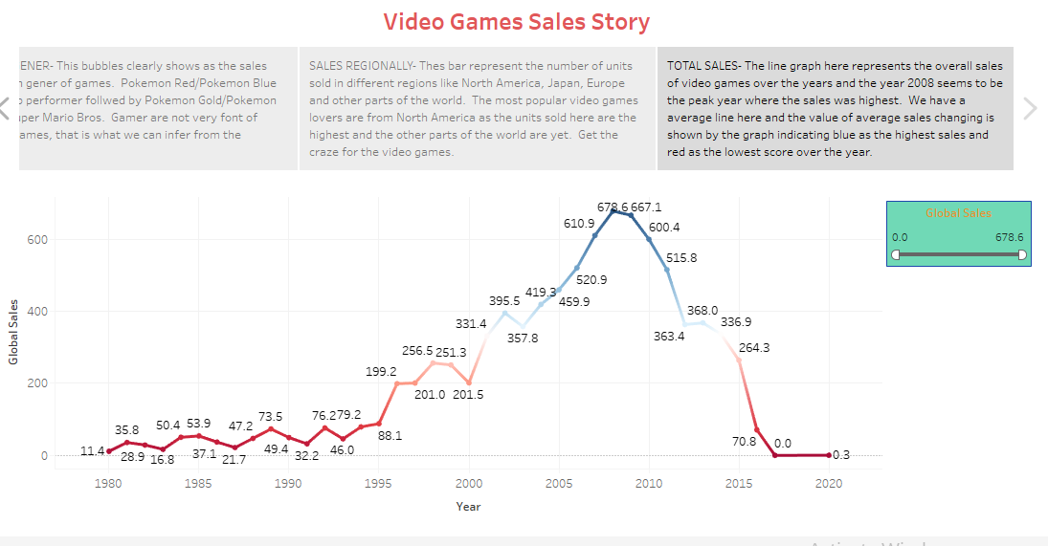

**4** ADVANTAGES & DISADVANTAGES

4.1 Advantages :

* Decision making Help enhance hand to eye coordination and improves motor skills
* Promote togetherness,teamwork, and sociability among people
* Help ease physical emotional pain and depression
* Help improve vision ,especially those with accelerated images
* Help in improving skills
* Video games can increase creativity by taking a break from the problems life presents.
* Many video games require players to think critically and solve problems in order to progress through the game.
* Certain types of video games, such as puzzle games, can help improve memory and cognitive function.

4.2 Disadvantages :

* Depression and social anxiety.
* Lack of motivation.
* Poor emotional regulation.
* Poor sleep hygiene.
* Muscle loss and fat gain.
* Addiction.
* Violence.
* Social Replacement.
* Dehydration.
* Exhaustion.

1. APPLICATIONS

Game development software applications are tools that help game developers make video games. They typically simplify processes such as converting assets, designing, level editing, compilation, simulation, testing and debugging.

The combination of concentration and neurotransmitter surges when playing games helps to strengthen neural circuits, giving the brain a real workout. Video games can improve mental skills, such as: Problem solving and logic. Hand-eye coordination, spatial skills and fine motor coordination.

* They speed up response times. ...
* They encourage teamwork. ...
* They stimulate creativity, focus and visual memory. ...
* They improve strategy and leadership. ...
* They teach languages. ...
* Critical thinking.

1. CONCLUSION

Video games are a form of media that is often associated with negative health consequences. However, when games are played in moderation and with mindfulness, they are a viable source of stress relief as well as a catalyst for mental health improvement and development of social skills.

7 FUTURE SCOPE

Video gaming, once seen as an addictive hobby, can actually make the world a better place through science and technology. By inspiring students to pursue careers in STEM fields and helping solve real-world problems, video games have taken on an entirely new light in recent years.  In fact, there are a lot of reasons to play video games that have nothing to do with entertainment: They just might help solve our world’s most pressing problems. Video games are powerful tools for building problem-solving skills. In fact, in a growing number of cases, what is considered to be good gaming has very little to do with winning or losing at all—the act of solving problems, by itself, is what brings a lot of gamers satisfaction. With that in mind, video games may be exactly what we need as civilization attempts to tackle some of its biggest challenges.

8 APPENDIX

Source Code :

file:///D:/Uncovering%20the%20Gaming%20Industry's%20Hidden%20Gems%20%20A%20Comprehensive%20Analysis%20of%20Video%20Games%20Sales/Assets/project.html